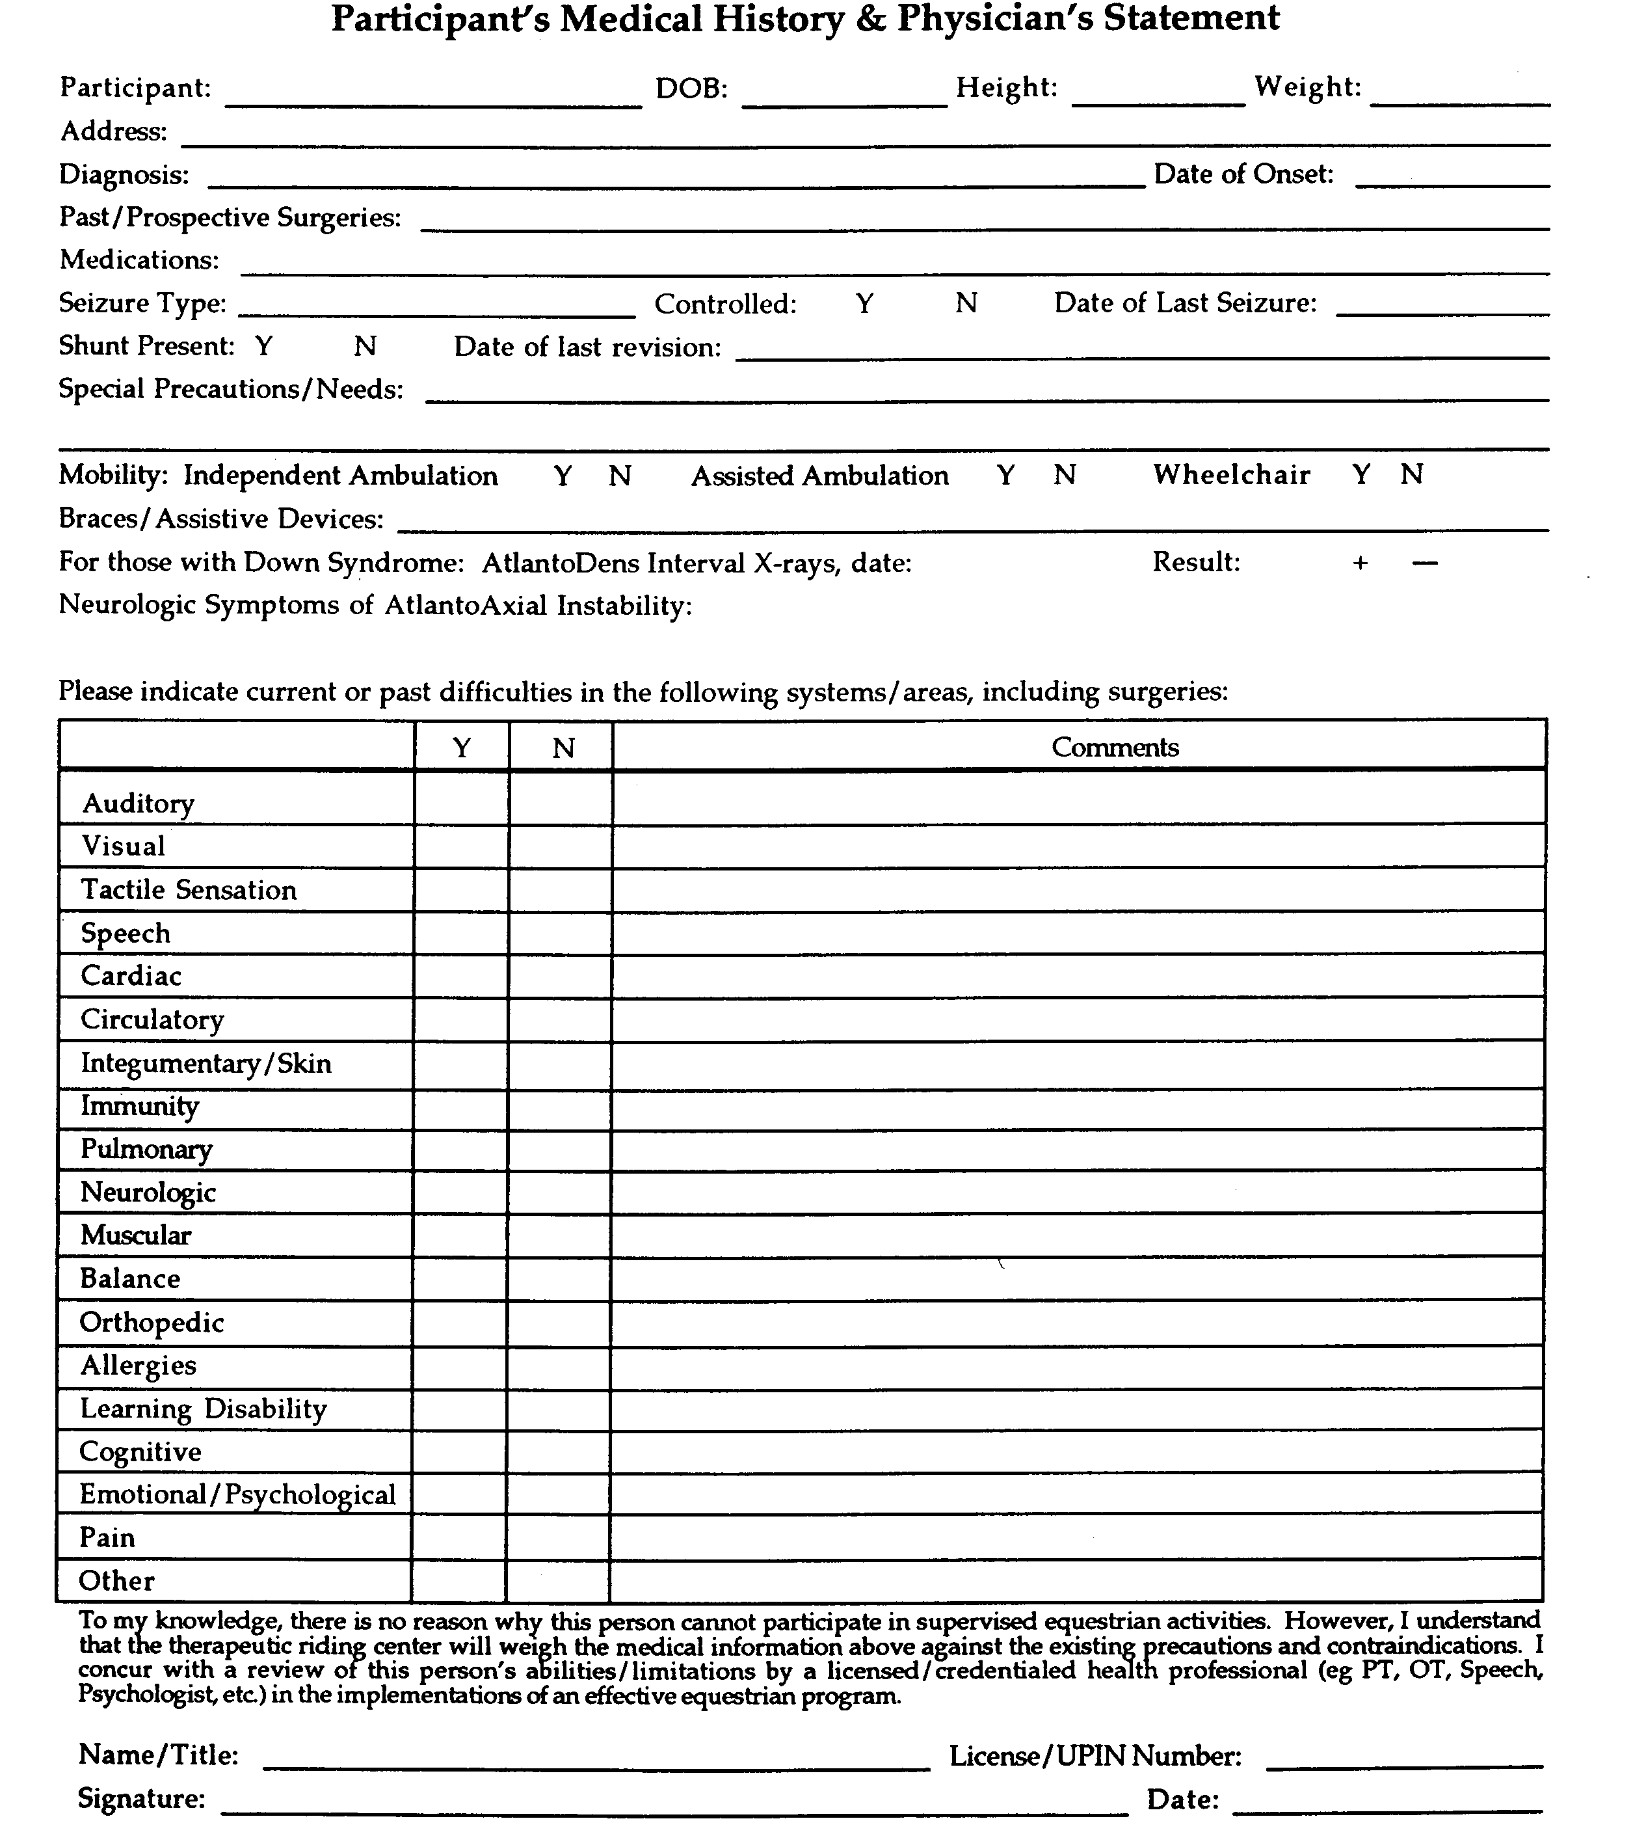
SPIRITHORSE THERAPEUTIC RIDING CENTER
Contraindications and Physician’s Medical Release

Date:

Dear Physician:

Your patient, , is interested in participating in supervised equestrian activities. In order to safely provide this service, our operating center requests that you complete/update the Medical History & Physician’s Statement Form. Please note that the following conditions may suggest precautions and contraindications to therapeutic horseback riding. Therefore, when completing this form, please note whether these conditions are present, and to what degree.

ORTHOPEDIC MEDICAL/PSHCHOLOGOCAL
Atlantoaxial Instability - include neurologic symptoms Allergies
Coxa Arthrosis Animal Abuse
Cranial Deficits Physical/Sexual Emotional Abuse
Heterotopic Ossification / Myositis Ossifications Blood Pressure Control
Joint Subluxation Dislocation Dangerous to self or others
Osteoporosis Exacerbations of medical conditions
Pathologic Fractures Fire Settings
Spinal Fusion / Fixation Heart Conditions
Spinal Instability / Abnormalities Hemophilia
Medical Instability
NEUROLOGIC Migraines
Hydrocephalus/Shunt PVD
Seizure Respiratory Compromise
Spina Bifida / Chiari II malformation/Tethered Cord Recent Surgeries
Hydromyelia Substance Abuse
Thought Control Disorder
OTHER Weight Control Disorder
Indwelling Catheters
Medications - i.e. photosensitivity
Skin Breakdown

Thank you very much for your assistance. If you have any questions or concerns regarding this patient’s participation in therapeutic equine activities, please feel free to contact the operating center at the address/phone indicated below.

Sincerely, SpiritHorse Therapeutic Riding Center

Client’s Name: Phone:

Physician’s Signature: Date:

SpiritHorse Therapeutic Riding Center, 1962 Suncrest Drive, Prattville, Alabama 36067

SPIRITHORSE THERAPEUTIC RIDING CENTER
Authorization for Emergency Medical Treatment Form
( ) Participant ( ) Visitor ( ) Volunteer

Name: _______________________________________________________________________
DOB: _______________________ Phone: ________________________________________
Address: ______________________________________________________________________
Physician’s Name: ___________________
E-MAIL Address: _____________
Medical Facility: _______________________________________________________________
Health Insurance Company: _____________________________________________________
Policy #: ______________________________________________________________________
Allergies to medications: _____________
Current medications: ___________________________________________________________

In the event of an emergency, contact:

Name: Relation: Phone: __________

Name: Relation: Phone: __________

In the event emergency, medical aid / treatment is required due to illness or injury during the process of receiving services, or while being on the property of the agency, I authorize SpiritHorse Therapeutic Riding Center to:

1. Secure and retain medical treatment and transportation if needed.
- Release client records upon request to the authorized individual or agency involved in the medical emergency treatment.

Consent Plan
This authorization includes x-ray, surgery, hospitalization, medication, and any treatment procedure deemed “lifesaving” by the physician. This provision will only be invoked if the person(s) above is unable to be reached.

Date: Consent Signature:
Client, Parent, or Legal Guardian
Non-Consent Plan
I do not give my consent for emergency medical treatment! aid in the case of illness or injury during the process of receiving services or while being on the property of the agency. In the event emergency treatment/ aid is required, I wish the following procedures to take place:

Date: Consent Signature:
Client, Parent or Legal Guardian

Release of Liability
This Release of Liability is made and entered into on this date_____________________ and for thereafter
between Gayle Thorn (Executive Director), SpiritHorse Therapeutic Riding Center, and (The Participant) _____________________________________; and, if Participant is a minor, their Parent or Legal Guardian (father)_________________________________(mother)_________________________________ In return for the use, today and on future dates, of the property, facility and services of the Executive Director, the Participant, his heirs, assigns and legal representatives, hereby expressly agree to the following:
1. Participant agrees to assume any and all risks involved in or arising from participant’s use of or presence upon Executive Director’s property and facility including without limitation the risk of death, bodily injury, property damage, all kicks, bites, collisions with vehicles, horses, or stationary objects, fire or explosion, the unavailability of emergency care, or the negligence or deliberate act of another person.
2. Participant agrees to hold Executive Director and all its successors, assigns, subsidiaries, franchises, affiliates, officers, directors, employees and agents completely harmless and not liable, and releases them from all liability whatsoever, and Agrees Not To Sue them on account of, or in connection with any claims, causes of action, injuries, damages, costs or expenses arising out of the Participant’s use of or presence upon Executive Director’s property and facility, including without limitation, those based on death, bodily injury, property damage, including consequential damages, except if the damages are caused by the direct, willful and wanton negligence of the Executive Director.
3. Participant agrees to waive the protection afforded by any statute or law in any jurisdiction whose purpose, substance and/ or effect is to provide that a general release shall not extend to claims, material or otherwise which the person giving the release does not know or suspect to exist at the time of executing this release.
4. Participant agrees to indemnify and defend Executive Director against, and hold it harmless from any and all claims, causes of action, damages judgments, costs or expenses, including attorney’s fees, which in any way arise from the Participant’s use of or presence upon the Executive Director’s property or facility.
5. Participant agrees to abide by all of the Executive Director’s safety rules and regulations.
6. This contract is non-assignable and non-transferable, and is made and entered into in the State of Alabama, and shall be enforced and interpreted under the laws of this State. Should any be in conflict with State law, then that clause is null and void. When the Executive Director and Participant, or Participant’s Parent or Legal Guardian if Participant is a minor, sign this contract, it will then be binding on both parties, subject to the above terms and conditions.

RELEASE AND INDEMNITY AGREEMENT
In consideration of the acceptance of my participation and/or the participation of my child or ward, in the renting of a horse from or related activities offered by the Spirithorse TRC at the Mercy Seat, and with the understanding that a horse may be startled by sudden movement, noise or other factors, and may shy suddenly, rear, stop short, bite, buck, kick or run with its rider, especially when the ride is conducted through an unnatural setting, as this activity will be, I AGREE TO ASSUME THE RISKS incidental to such participation including, but not limited to, those risks set out above, and, on my own behalf, on behalf of my child or ward, and on behalf of my child's or ward's heirs, executors and administrators, RELEASE and forever discharge the released parties defined below, of and from all liabilities, claims, actions, damages, costs or expenses of any nature, arising out of or in any way connected with my participation and/or the participation of my child or ward in such horseback riding or related activities and further agree to indemnify and hold each of the released parties harmless against any and all such liabilities, claims, actions, damages, costs or expenses, including, but not limited to, attorney's fees and disbursements. The released parties are the Spirithorse TRC at the Mercy Seat, their parent, related, affiliated and subsidiary companies, and the officers, directors, employees, agents, representatives, successors and assigns of each. I understand that this release and indemnity agreement includes any claims based on the negligence, actions or inaction of any of the above released parties and covers bodily injury and property damage, whether suffered by me, my child or ward before, during, or after such participation. I further authorize medical treatment for said child or ward, at my cost, if the need arises.

WARNING: Under Alabama law, an equine activity sponsor or equine professional is not liable for an injury to or the death of a participant in equine activities resulting from the inherent risks of equine activities, pursuant to the Equine Activities Liability Protection Act.

Photo release- please check one:
□ I consent to and authorize the use and reproduction of any and all photographs and any other audio-visual materials taken of me or my child for promotional material, educational activities, and exhibitions or for any other use for the benefit of the program.
□ I do not consent to the use and reproduction of photographs and other audio-visual materials taken of me or my child for any purpose.

Parent Father _______________________________________ Date _______________________

Parent Mother ______________________________________ Date ________________________

SPIRITHORSE THERAPEUTIC RIDING CENTER

Pare Name of Current School: _______________________________________________________

APPLICANT HEALTH HISTORY
Please describe applicant’s FUNCTIONAL abilities and difficulties, such as: mobility skills (transfers, walking, wheelchair use, driving/bus riding):
____________________________________________________________________________
Please describe applicant’s SOCIAL abilities and difficulties, such as: work/school (grade completed, leisure interests, relationships-family structure, support systems, companion animals, fears/concerns, etc.):
_____________________________________________________________________________
Any Allergies specific to being outside in nature:
___________________________________________________________________

APPLICANT INFORMATION
Goals (reason for applying; what would you like to see accomplished):

Please tell us about the applicant. (Likes: Favorite food, hobbies, pets, home life, siblings) (Dislikes: pets, sounds, etc.):

What types of things work best for the applicant in terms of rewards and motivation?

How does the applicant best communicate with others?
□ Spoken Language
□ Sign Language □ASL □E/E
□ Written Language
□ Communication device
□ Combination of the above (please describe)

Does the applicant use:

□ Echolalia (repeating words without regard for meaning)
□ Stemming (rocking, spinning, hand flapping)
□ Self-Regulatory Behavior

Please describe how the applicant uses this self-soothing behavior):

Do changes in the applicant’s environment affect their behavior?

□ Never □ Sometimes □ Frequently

Please return to: SpiritHorse TRC
1962 Suncrest Drive
Prattville, Al 36067

Or Email to: spirithorsetrc@yahoo.com

Any questions contact Gayle Thorn at 334-531-7019

